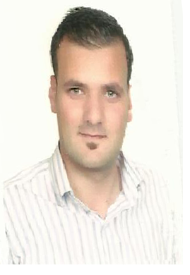

Shadi Mohammad

Web Developer

 Deira / Dubai / UAE 052 2536654

 shadi.alahmd@gmail.com

|  |  |
| --- | --- |
| Technical Skills | Languages: php, Java, C#, Ruby. ★★★★★★★★★★  Operating Systems: Linux, Windows, Mac OS. ★★★★★★★★★★  Databases: SQL, MySQL, Big Data. ★★★★★★★★★★  Computer Graphics: Illustrator, Photoshop. ★★★★★★★★★★  Web Tools: HTML5, JavaScript, JQuery, React, Bootstrap. ★★★★★★★★★★ |
| Other Skills | * Excellent communication skills * Excellent in creating reports, manuals, documents, and help files. * Excellent knowledge of social platforms, Git and GitHub. * Analysis and optimization of website speed. * Analysis and optimization of search engines (SEO). * Proficient in using (Word Press) content management system. * Knowledge of Google products like (Adwords, Adsense, Analytics). |
| Experience | web Developer Jan 2017 – Present  Atlas Telecom   * Develop and maintain multiple application solutions. * Develop and direct software system testing and validation procedures. * Modify existing software to correct errors.   web developer Jan 2014 – Jan 2017  Smart Vision   * Design data structures that meet application requirements. * Design/code applications requiring a high degree of complexity. * Support software applications to resolve any defects and issues reported. * Integration of user-facing elements developed by front-end developer.   web developer (TRAINEE) May 2013 – Jan 2014  Savvytek   * Develop & suggest responsive coding best practices. * Ensure website uptime, content quality, interface monitoring. * Coordinate with outside vendors, as needed to accomplish goals. * Enforce standards and review code where necessary. |
| Education | **B.Sc. of Computer Science 2009 - 2013**  Jordan University of Science and Technology (J.U.S.T) |
| Languages | **Arabic** (Native)  **English** (Excellent) |
| Personal information | **Nationality:** Jordanian  **Marital status:** [Married](https://www.google.com/search?q=married&spell=1&sa=X&ved=2ahUKEwjtpd7Qo4nsAhUStRoKHSubB1QQBSgAegQICxAn)  **Place and Date of Birth**: Jordan, November 21st, 1991 |
| Projects | Crisis Management Application (Abu Dhabi Police)Design and develop software that can handle big events and day-to-day events through WebEOC.Crisis Management Application (Ministry of Health)Understand safety and healthcare procedures that occur during crisis and translate them into automotive procedures.Crisis management Application (ARAMCO)Understand safety procedures and translate them into automotive procedure, dealing with notification tool (ATHOC) to send SMS and calls to users, dealing with map (ArcGIS from Esri) to make events show on the map during abnormal events. **HCCertificate Kiosk** (Department of Finance, ADMA)  As As HR departments cannot handle the large number of requests to print certificates,  this this allows users to print all types of certificates --stamped and signed.    **HCCertificates of Origin Kiosk** (Ajman Chamber)  This Allows the end users to print the Certificates of Origin without going to  the Ajman Chamber**.** |